**IFT 266 Introduction to Network Information Communication Technology (ICT)   
  
Lab 44**

**Connecting multiple IPv6 networks**

Co-authored by Jason Miller

**Notes on the lab**

The primary routing prefix for this organization is 2001:abcd:aaaa::/64

The organization has multiple sites, each of which are setup as a subnet.

The challenge of this lab is to get the connections online for all sites and all sites communicating with each other.

**Tip:** You may want consider using the 2811 router as opposed to the ISR 4321 routers.

1. Setup the following topology within Packet Tracer

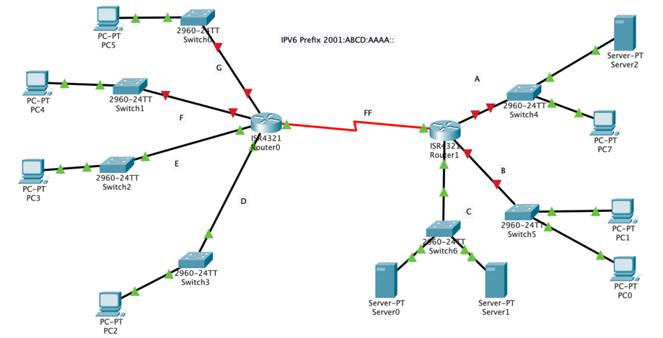

**Note:** You may need to add additional modules to the routers and switches to connect the devices.



1. We will first configure Router 0 with the following commands.   
     
   We will start by enabling unicast routing for IPv6 and then configure the serial port on the router with an IPv6 address.

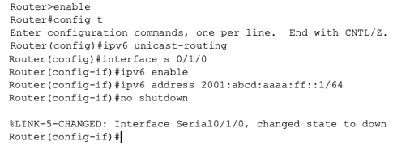

We have now configured one side of the serial link between the routers



1. Configure Router 1 to get the link up between the two routers.  
     
   Make sure you can ping between the two routers, troubleshoot if necessary.



1. Now configure each of the subnets attached to both routers using the subnets as labeled on the topology (similarly in how you configured the serial ports on the routers).



1. Using the auto-config method, get the PCs and servers connected to their appropriate networks.



1. Given what we have configured so far, you should now be able to ping the networks on their respective routers. For example, based on our original topology, PC 2 on Subnet D should be able to ping PC 5 on Subnet G. Troubleshoot if required.   
     
    Insert an image of the successful ping between PC 2 and PC 5 below.   
     
     
     
     
   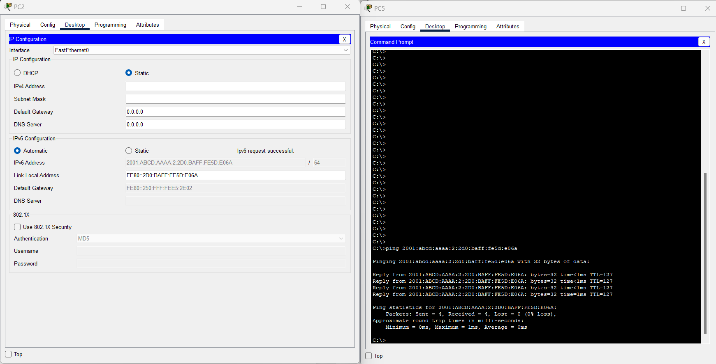
2. If you attempt to ping Server 2 from PC 5 what happens?   
     
    No

Why?   
  
 We have no setup the routing protocols for the server

What are 2 different methods (do not say tunnelling) that we could use to make communication happen?

Static routing or dynamic routing.

1. We now enable the unicast routing protocol “RIP” that we introduced in the earlier networking course on both routers to get the routers to advertise their respective networks.

We will first create the RIPng process/group named “Elephant” and then enable RIPng on each router

interface as shown in the configuration below.   
  
 You will need to specify the correct interfaces on your routers.

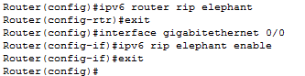  
  
Remember, you will need repeat this command “ipv6 rip elephant enable’ on each router interface on both routers



1. Now you should have connectivity and routing for every host on each network.

Now attempt to ping Server 2 from PC 5……it should work, If not, troubleshoot.  
  
Insert an image of the successful ping between Server 2 and PC 5 below.

